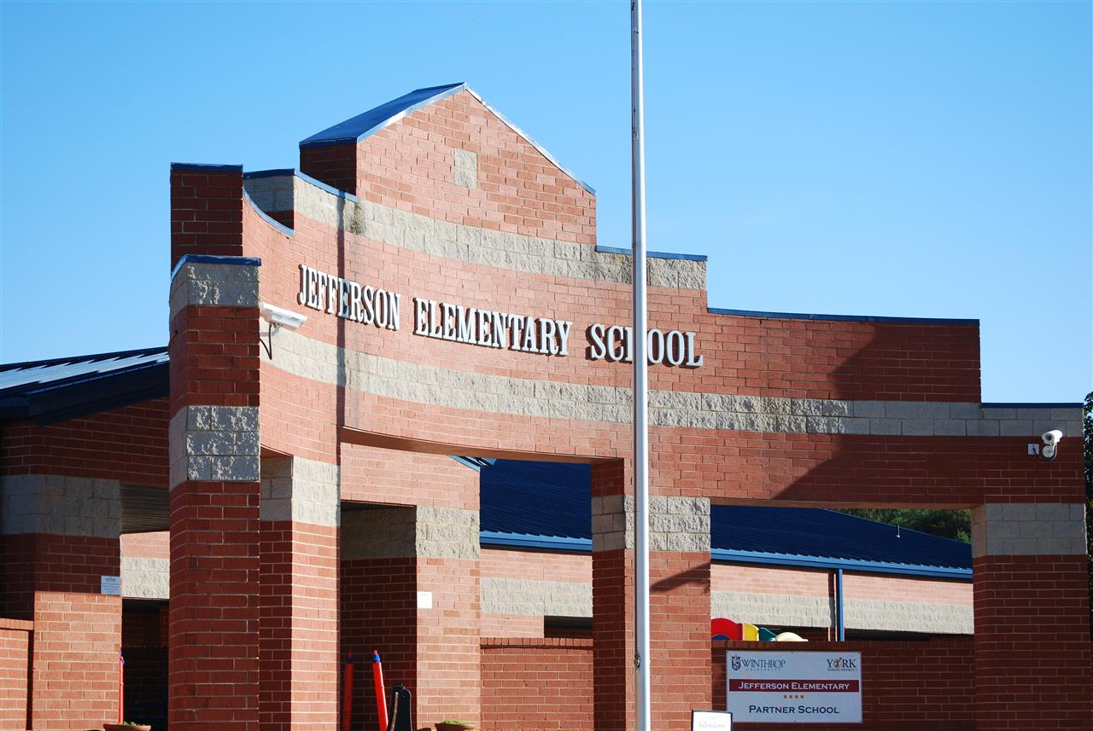

MINIMUM CAPACITY :-
The Minumum intake capacity
of students is between 300-620
children

LIBRARY :-
The Libarary is Available.

CANTEEN:-
The Canteen Facility is Available.

BOARDING :-
No availablility of boarding.

SPORTS :-
There are different categories
sports available.
Girls Volleyball
Boys Volleyball
Football

JEFFERSON ELEMENTARY SCHOOL
UTICA - SCHOOL

School Detail :-
At Jefferson, we are committed to meeting and exceeding state and national academic standards. While encouraging our students to strive to become kind, caring, and compassionate productive members of society.
. While encouraging our students to strive to become kind, caring,

